Prima Donna AI Android App Handoff
Prepared: June 13, 2026
Repository: https://github.com/david54766/hello2-greeting-page.git
Branch: codex/android-native-migration
Current commit at handoff: 3f84e6e
Current debug APK: G:\My Drive\Prima Donna AI - Android Debug - 2026-06-13.apk

1. Original Build Prompt
The initial request that started this Android build was:
I need to build a native android mobile app for this site please review and scope out how we can do this.
>
Here is the elite client login so you can view the full layout.
>
URL: https://app.thepreschoolprimadonna.com/login
Email: info@easyfill.ai
Temp password: [REDACTED FOR HANDOFF]
Security note: do not paste live passwords, OpenAI keys, ElevenLabs keys, Supabase service role keys, or Stripe secrets into the repo or this document. Keep credentials in the Mac machine's secure password store or environment/secret manager.

2. Current Product State
This repository now contains a native Android implementation for Prima Donna AI. The Android app is a Kotlin Jetpack Compose application inside the existing Lovable/TanStack web repo. The native app talks directly to Supabase REST/Auth plus a Supabase Edge Function named mobile-api for mobile-safe server operations.
Stripe billing is intentionally excluded from the Android build for now. The app only displays current plan status in Settings.
Current confirmed native screens:
Sign in with centered brand, email/password, forgot password, and debug-only temp sign-in.
Home dashboard locked around center snapshot, facility goal, and Raven daily brief card.
Coaching Engine with fixed strategy prompt, mode chips, strategy-ready popup, previous strategy history, and Raven voice playback.
Template Vault with one-line horizontal category filters and resource cards.
Elite Circle defaulting to conversations with Book with Raven entry into scheduling.
Settings with profile, centers, notification preferences, current plan, and add/edit center flows.

3. Mac Setup Instructions
Clone the repo:
- git clone https://github.com/david54766/hello2-greeting-page.git
- cd hello2-greeting-page
git checkout codex/android-native-migration
Open the project in Android Studio.
Create or update local.properties at the repo root. Do not commit it.
- SUPABASE_URL=https://owjhaoiqiujpdndcwccl.supabase.co
- SUPABASE_ANON_KEY=<publishable or anon Supabase key>
- QA_EMAIL=<debug temp-login email>
- QA_PASSWORD=<debug temp-login password>
- WEB_APP_URL=https://app.thepreschoolprimadonna.com
AUTH_REDIRECT_URL=preschoolprimadonna://auth-callback
Build from Android Studio or terminal:
./gradlew :app:assembleDebug
Debug APK location:
app/build/outputs/apk/debug/app-debug.apk
For a release build, add proper Android signing config first. The current APK is a debug build intended for device testing only.

4. Required Backend Secrets
Set these in Supabase Function Secrets for project owjhaoiqiujpdndcwccl:
Secret | Required | Purpose
OPENAI_API_KEY | Yes | Powers Coaching Engine strategy generation through `mobile-api/run_coaching`.
ELEVENLABS_API_KEY | Yes for Raven voice | Powers Raven voice playback through `mobile-api/synthesize_raven_voice`.
ELEVENLABS_RAVEN_VOICE_ID | Optional | Defaults to `EcNmy6NxONUCla9ZNPCn` if not set.
SUPABASE_URL | Yes | Automatically present for Supabase functions.
SUPABASE_ANON_KEY | Yes | Automatically present for Supabase functions.

The Android client must never receive OpenAI, ElevenLabs, Stripe, Resend, or Supabase service role secrets.

5. Android App Architecture
Main Android files:
File | Responsibility
app/src/main/java/com/preschoolprimadonna/app/MainActivity.kt | Compose UI, screen routing, navigation, dialogs, and screen layout.
app/src/main/java/com/preschoolprimadonna/app/PrimaDonnaViewModel.kt | App state, auth/session lifecycle, data loading, save actions, coaching, voice playback, and Elite workflows.
app/src/main/java/com/preschoolprimadonna/app/data/SupabaseRestClient.kt | Supabase Auth/REST calls, mobile Edge Function calls, storage signed URLs, and server function fallback calls.
app/src/main/java/com/preschoolprimadonna/app/data/Models.kt | Kotlin serializable data models.
app/src/main/java/com/preschoolprimadonna/app/ui/Theme.kt | Brand colors and Material theme.
supabase/functions/mobile-api/index.ts | Supabase Edge Function for AI, Raven voice, Elite board, and Raven scheduling.

6. Key Native Functions

Auth and Session
PrimaDonnaViewModel.signIn(email, password) signs in through Supabase Auth, stores the session, then loads all dashboard data.
PrimaDonnaViewModel.signUp(fullName, email, password) creates a Supabase Auth account and saves full_name as metadata.
PrimaDonnaViewModel.requestPasswordReset(email) sends a Supabase password recovery email using the native app redirect URL.
PrimaDonnaViewModel.handleAuthRedirect(uri) handles preschoolprimadonna://auth-callback for login/recovery links.
SessionStore persists auth sessions locally.
Debug temp sign-in is controlled by BuildConfig.DEBUG, QA_EMAIL, and QA_PASSWORD.

Data Loading
PrimaDonnaViewModel.loadData(session) loads profile, subscription, centers, templates, videos, coaching sessions, Elite threads, Raven slots, and Raven bookings in parallel.
PrimaDonnaViewModel.withRefreshRetry(...) retries requests after token refresh when a session expires.

Centers and Profile
saveProfile(...) updates business profile details.
addCenter(center), updateCenter(center), and deleteCenter(centerId) manage the user's center portfolio.
Home reads center data to display enrollment, estimated revenue, and facility goal/capacity.

Coaching Engine
submitCoachingPrompt(mode, prompt) sends a strategy request to mobile-api action run_coaching.
StrategyReadyDialog(...) shows the generated recommendation immediately after a new coaching session returns.
CoachingHistoryDrawer(...) shows previous sessions.
playRavenVoice(session) turns saved strategy text into an MP3 using mobile-api action synthesize_raven_voice, saves the MP3 to cache, and plays it through Android MediaPlayer.
stopRavenVoice() releases playback state.

Template Vault
VaultScreen(...) filters templates by category using a one-line horizontal chip row.
Template downloads use signed storage URLs through viewModel.signedUrl("templates", path).

Elite Circle
EliteScreen(...) defaults to Conversations.
createEliteThread, openEliteThread, replyEliteThread, and deleteEliteThread call mobile-api Elite thread actions.
Book with Raven switches into the schedule tab.
bookRavenSlot(slot, topic) and cancelRavenBooking(bookingId) call mobile API scheduling actions.

7. Supabase Edge Function: `mobile-api`
File: supabase/functions/mobile-api/index.ts
Actions:
Action | Access | Purpose
run_coaching | Authenticated user | Uses OpenAI `gpt-4o-mini` and stores a structured coaching response in `coaching_sessions`.
synthesize_raven_voice | Authenticated user | Uses ElevenLabs and returns base64 MP3 audio for Android playback.
list_elite_threads | Elite/admin | Returns Elite board threads with author names and reply counts.
create_elite_thread | Elite/admin | Creates a conversation.
get_elite_thread | Elite/admin | Returns a thread with replies.
reply_elite_thread | Elite/admin | Adds a reply.
delete_elite_thread | Elite/admin | Deletes a thread.
list_raven_slots | Elite/admin | Generates open Raven booking slots.
list_raven_bookings | Elite/admin | Lists the current user's active Raven bookings.
book_raven_slot | Elite/admin | Books a Raven session.
cancel_raven_booking | Elite/admin | Cancels a booking.

Access rule: all Elite board/scheduling actions require an active elite subscription or admin role. Coaching and voice are authenticated-user actions.

8. Visual and Layout System
Theme tokens are in Theme.kt:
Token | Value | Usage
PrimaPink | #F000A8 | Primary brand action/accent.
PrimaInk | #171016 | Body/heading ink.
PrimaSurface | #FFF7FA | Rose off-white app background.
PrimaSoft | #FFEEF6 | Bottom bar and soft selected states.
PrimaGold | #C49A48 | Elite/pro badges.
Outline | #EBD9E3 | Card and field borders.

Layout conventions:
Screen background should remain rose off-white, not pure white.
Cards should be white, bordered, and use AppCardShape = RoundedCornerShape(8.dp) unless explicitly a pill.
Screen headings use serif typography and large scale.
Badges use uppercase text, pill radius, subtle fill, and light border.
Bottom navigation has five tabs: Home, Coach, Vault, Elite, Settings.
Billing is intentionally removed from the app.
Elite icon uses a crown drawable and pink outline when selected.
Horizontal chip rows should stay one line and scroll sideways instead of wrapping.
Avoid nested decorative cards. Use simple cards only for repeated items, dialogs, and data surfaces.

9. Screen Layout Instructions

Sign In
Center logo at top.
White elevated card with large serif "Sign in" heading.
Fields: Email, Password.
Actions: Forgot password, Enter Command Center, Temp sign in.
Temp sign-in is debug-only and should not appear in release builds unless intentionally enabled.

Home
Locked snapshot view; avoid vertical content sprawl.
Header row: "Center snapshot" left, Elite or Pro badge right, badge slightly lower than heading baseline.
Center name badge appears under title.
Snapshot cards: Enrollment, Est. Monthly Revenue, Facility Goal.
If multiple centers exist, snapshot cards scroll sideways.
Strategic recommendation card sits below snapshot.

Coach
Fixed coaching session layout.
One-line horizontal mode chips: CEO, Revenue, Marketing, Compliance, Systems.
Prompt box must be white.
Primary action row: Speak and Move.
Previous strategies button sits below Speak/Move, centered and tightened.
Strategy-ready dialog uses rose off-white background.
Previous strategies drawer uses compact white cards with Details and Play on the same row.

Vault
One-line horizontal category filters.
Template cards use category/tier badges, title, description, Details, Download.
Keep cards white with light border and no heavy decoration.

Elite
Default tab is Conversations.
Show Book with Raven button above latest conversations.
Schedule tab handles bookings and open slots.
Current bottom nav icon is a centered crown with selected pink outline.

Settings
Business profile card.
Notification preferences card.
Centers list with edit/delete.
Add center opens a polished white dialog with consistent field shapes.
Membership card displays only current plan/status/current period.
Do not reintroduce billing plan comparison cards in Android.

10. Build and Verification Checklist
Before handing another APK to a tester:
./gradlew :app:assembleDebug :app:lintDebug :app:testDebugUnitTest
Then copy:
app/build/outputs/apk/debug/app-debug.apk
to:
G:\My Drive\Prima Donna AI - Android Debug - YYYY-MM-DD.apk
Latest successful Android checks passed on this branch:
:app:assembleDebug
:app:lintDebug
:app:testDebugUnitTest

11. Known Constraints and Follow-Ups
Current APK is a debug APK, not a signed release build.
Stripe billing is intentionally ignored for Android at this stage.
iPhone/iOS implementation has not been built yet.
Native app still depends on Supabase schema and seed/content data already existing.
For production, remove or gate debug temp sign-in.
For Play Store, add release signing, versioning, app icon validation, privacy policy, and production QA.

12. Current Visual References
The attached screenshots are the target state for visual continuity:
Login screen: centered brand, sign-in card, temp sign-in.
Elite Circle: conversations default, Book with Raven, latest conversations.
Template Vault: one-line filters, template cards.
Coaching Engine: white prompt box, Speak/Move row, tightened previous strategies.
Home: center snapshot, Elite badge, center metrics, strategic recommendation.
See the embedded screenshots in the Word version of this handoff for layout reference.

Embedded Sample Layout Screens

1. Login screen
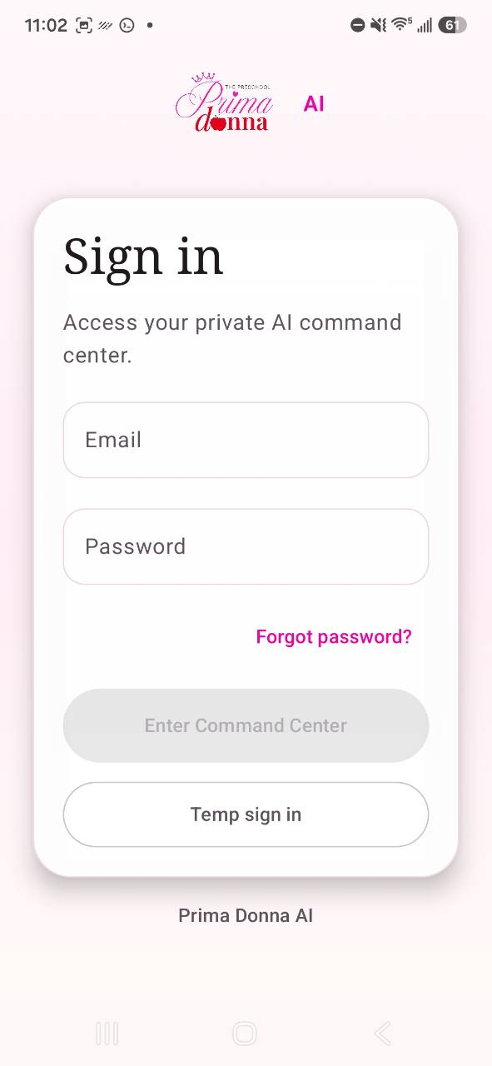

2. Elite Circle conversations
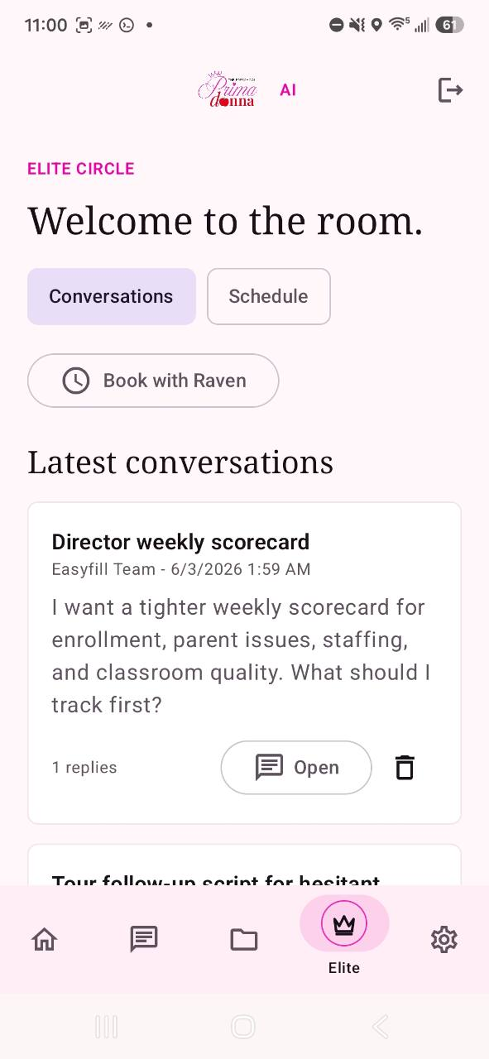

3. Template Vault
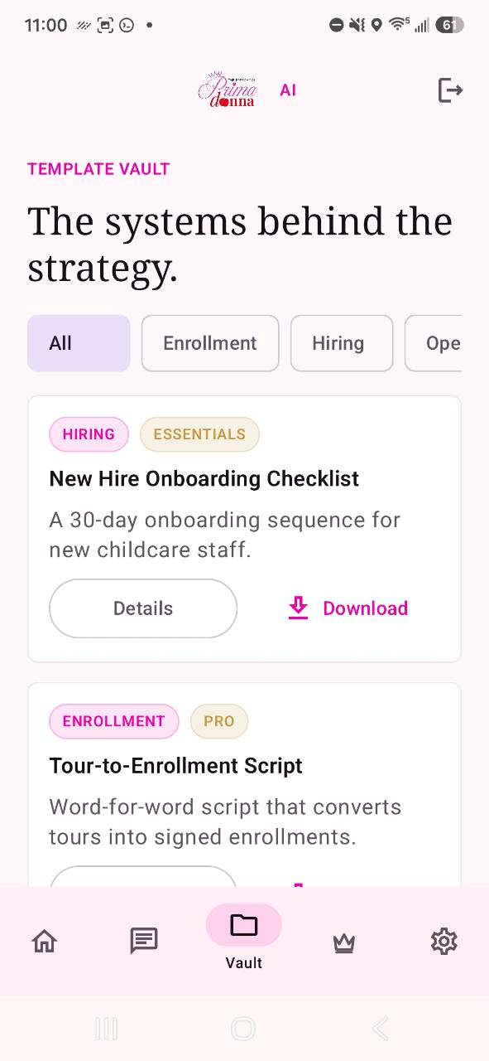

4. Coaching Engine
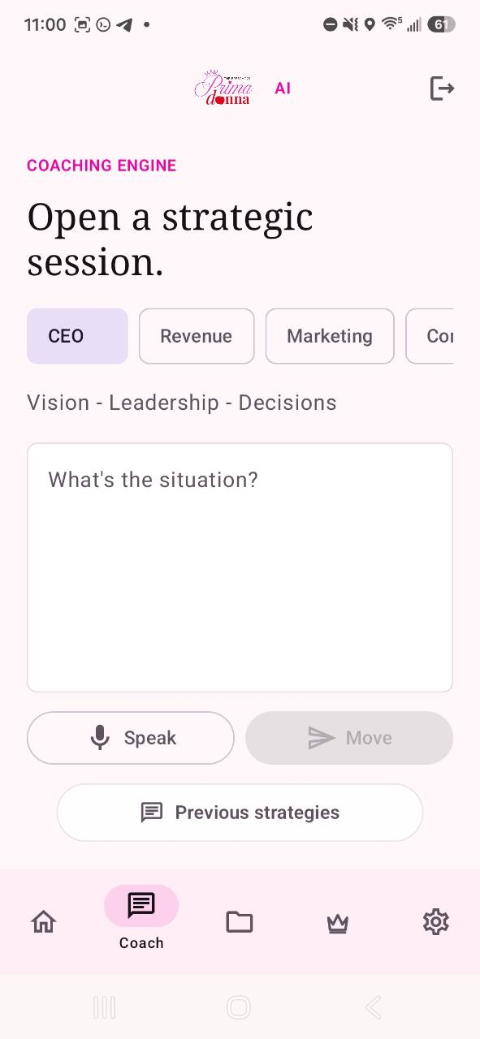

5. Home center snapshot
